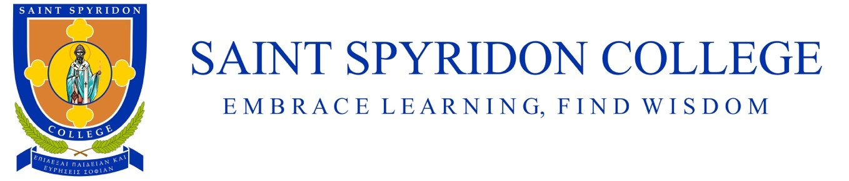

Saint Spyridon College School Uniform - 2021
Formal Summer Uniform (T1 & T4)
Girls
Boys

Summer dress with SSC logo
Navy bucket hat
Enclosed formal black shoes or sandals
Above-ankle navy socks
Formal summer shirt with SSC logo
Formal navy shorts
Navy bucket hat
Enclosed formal black shoes.
Above-ankle navy socks

Saint Spyridon College School Uniform - 2021
PE Uniform (unisex)
Warm Weather

Navy bucket hat
PE polo shirt
Micro fibre PE shorts with SSC logo
Above-ankle white socks
Sports sneakers

Cold Weather

PE long-sleeve rugby top
PE polo shirt
Green track pants with SSC logo
Above-ankle white socks
Sports sneakers
PE Track Jacket – optional

Saint Spyridon College School Uniform - 2021
Formal Winter Uniform (T2 & T3)
Boys
Girls

Formal white long sleeve shirt (with SSC logo)
(blue to be phased out by 2021)
Navy tie
Blazer
Navy jumper
Formal navy trousers
Enclosed formal black shoes
Above-ankle navy socks
Formal white long sleeve shirt
(blue to be phased out by 2021)
Navy tie
Blazer
Navy jumper
Winter pinafore
Enclosed formal black shoes
Above-ankle navy socks or stockings/tights

