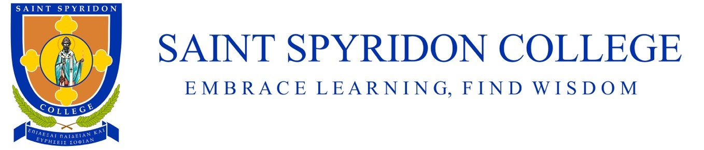
Uniform Policy 2021

Rationale
As a college, we are committed to preparing our students for life beyond school and instilling in them a recognition that they are part of a community. We wish students to feel proud of their school and their own appearance. Issues of equality, health and safety and expense have all been taken into consideration in establishing the school uniform.

Aims
- To develop a pride and identification with our school.
- To enhance and maintain a positive image for the school
- To develop in students a responsibility for their appearance and awareness of dress code required for work life.
- To provide durable clothing that is practical for our school environment.

Implementation
Saint Spyridon College had developed a Uniform Policy and Dress Code that allows students to safely engage in the many various school activities.
- The Dress Code applies during school hours (8:50am – 3:30pm), while travelling to and from school, and when students are off-site participating in school excursions.
- There is a Winter Uniform, Summer Uniform, and Sports Uniform as prescribes below.
- Summer Uniform is required to be worn in terms 1 and 4 of the school year.
- Winter Uniform is required to be worn in terms 2 and 3 of the school year.
- During the first two weeks of term 2 and 4, either summer or winter uniform will be permitted.
- Wearing the school blazer is compulsory when travelling to and from school.
- Items that can be worn all year round depending on weather are: The formal uniform school jumper on formal uniform days; the PE rugby jumper, PE track pants and PE shorts on sport uniform days.
- The bucket hat may also be worn all year round depending on weather/UV index, but is compulsory during terms 1, 3 and 4.
- The only items of jewellery permitted are: a watch or fit bit, one pair of simple stud or sleeper earrings worn in the ears for girls, prayer rope worn around the neck or wrist or any other jewellery with religious significance. Any jewellery outside this Dress Code will be confiscated and returned only the parent/guardian.
- Nail polish, make-up and extreme hair colours or hair styles are not permitted.
- Girls’ hair must be pulled up and away from the face and not left to hang down free of bonds.
- For girls, hair ties, scrunchies, ribbons, elastics etc. worn in the hair must be in school colours (navy blue, dark green, red or yellow)
- Practical/functional sunglasses may be worn according to Saint Spyridon College’s SunMart policy.
- Students are permitted to wear only the school bucket hat when required. Beanies, balaclavas and other non-uniform headgear are not permitted.
- White skivvies, undershirts etc. can worn underneath the school uniform provided they are not obviously visible.
- New school uniforms can be purchased from Devon Clothing.
- Various second-hand uniform items may be available from the Saint Spyridon College front office at 50% of the original sale price.
- Second-hand uniform items can be donated to the school’s second-hand uniform shop. Families can request funds for these upon the sale of their item. Saint Spyridon College will retain a 20% handling fee.
- The school uniform Dress Code, including details of uniform items and purchase arrangements will be published on the school website and communicated to families at the beginning of each school year.
- The School Principal and Classroom Teachers are responsible for the implementation and enforcement of the Dress Code.
- Parent seeking exemptions to the Dress Code due to ethnic or cultural background, religious beliefs, student disability, health condition or economic hardship can communicate with the School Principal for consideration.

Policy Review
The school council and staff regularly monitor and review the Uniform Dress Code Policy (at least every three years) and revise the policy when required.

Date of next policy review: January 2022

